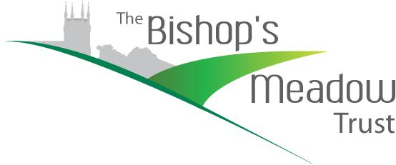

Gift Aid Declaration
for past, present & future donations
to The Bishop’s Meadow Trust

Please treat as Gift Aid Donations, all qualifying gifts of money made
Today *□ in the past 4 years *□ in the future *□
*Please tick all boxes you wish to apply

I confirm I have paid or will pay an amount of Income Tax and/or Capital Gains Tax for each tax year (6 April to 5 April) that is at least equal to the amount of tax that all charities or Community Amateur Sports Clubs (CASCs) that I donate to will reclaim on my gifts for that tax year. I understand that other taxes such as VAT and Council Tax do not qualify. I understand the charity will reclaim 25p of tax on every £1 that I give on or after 6 April 2009.

Please notify the charity or CASC if you:
• Want to cancel this declaration
• Change your name or home address
• No longer pay sufficient tax on your income and/or capital gains

Donor’s Details (IN BLOCK CAPITALS)
Title ____________ Full Name ___________________________________________________________
Full Home Address including Postcode _____________________________________________________
_____________________________________________________________________________________
Date _____________________________ Email ______________________________________________
Signature _____________________________________________________________________________

If you pay Income Tax at the higher or additional rate and want to receive the additional tax relief due to you, you must include all your Gift Aid donations on your Self Assessment Tax Return or ask HM Revenue & Customs to adjust your tax code.

Please return this form to: Nick Green, Membership Secretary for The Bishop’s Meadow Trust,
12 Searle Road, Farnham, Surrey, GU9 8LJ

